|  |
| --- |
| Circuit Theory |
| MATLAB Assignment - 2 |
| SAMBHAV R JAIN 107108103 |

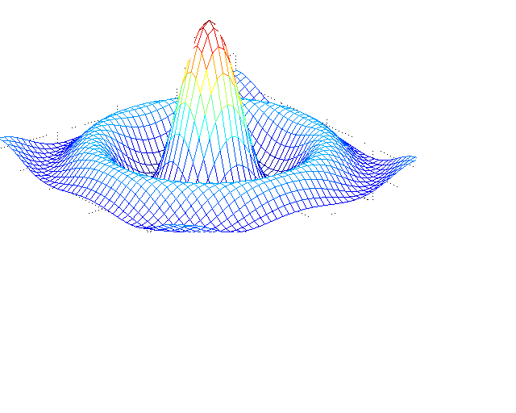

**Question 1**

**CIRCUIT DIAGRAM:**

**PROGRAM CODE:**

clear all;

close all;

clc;

disp('Enter the value of maximum voltage(Vm):');

Vm=input('');

disp('Enter the phase angle(deg) of V:');

th1=input('');

disp('Enter the value of maximum current(Im):');

Im=input('');

disp('Enter the phase angle(deg) of I:');

th2=input('');

% th1--theta1

% th2--theta2

% ph--phase angle

% pf--power factor

ph=(th2-th1)*pi/180;

pf=cos(ph);

disp('The power factor is:');

disp(pf);

Pavg=(Vm*Im*pf/2);

disp('The average power is:');

disp(Pavg);

Vrms=Vm/sqrt(2);

disp('The rms value of voltage is:');

disp(Vrms);

**OUTPUT:**

Enter the value of maximum voltage(Vm):

5

Enter the phase angle(deg) of V:

30

Enter the value of maximum current(Im):

6

Enter the phase angle(deg) of I:

60

The power factor is:

0.8660

The average power is:

12.9904

The rms value of voltage is:

3.5355

**Question 2**

**CIRCUIT DIAGRAM:**

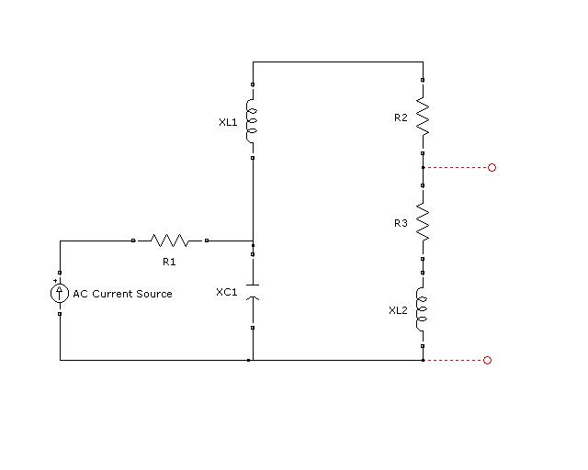

1. **To calculate Thevenin Resistance Rth:**

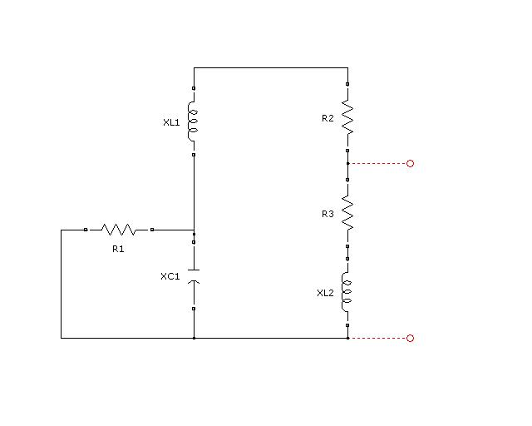

1. **To calculate Norton Current In :**

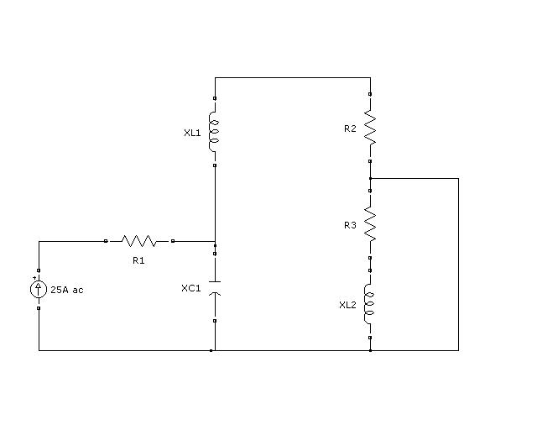

**PROGRAM CODE:**

clear all;

close all;

clc;

disp('Enter the value of current source:');

I=input('');

disp('Please enter the value of R1:');

R1=input('');

disp('Please enter the value of R2:');

R2=input('');

disp('Please enter the value of R3:');

R3=input('');

disp('Please enter the value of XL1:');

XL1=input('');

disp('Please enter the value of XL2:');

XL2=input('');

disp('Please enter the value of XC1:');

XC1=input('');

Zth=(R2+j*(XL1-XC1))*(R3+j*XL2)/(R2+R3+j*(XL1+XL2-XC1));

disp('The Thevenin impedance is calculated as:');

disp(Zth);

Isc=(i*(XC1*I))/(-R2+i*(XC1-XL1));

disp('The short circuit current is calculated as:');

disp(Isc);

Vth=Isc*Zth;

disp('The Thevenin voltage is calculated as:');

disp(Vth);

disp('The Norton equivalent current source is:');

disp(Isc);

disp('The value of Z(load) for maximum power transfer is:');

disp(conj(Zth));

**OUTPUT:**

Enter the value of current source:

25

Please enter the value of R1:

5

Please enter the value of R2:

4

Please enter the value of R3:

5

Please enter the value of XL1:

3

Please enter the value of XL2:

5

Please enter the value of XC1:

3

The Thevenin impedance is calculated as:

2.6415 + 0.7547i

The short circuit current is calculated as:

0 -18.7500i

The Thevenin voltage is calculated as:

14.1509 -49.5283i

The Norton equivalent current source is:

0 -18.7500i

The value of Z(load) for maximum power transfer is:

2.6415 - 0.7547i

**Question 3**

**CIRCUIT DIAGRAM:**

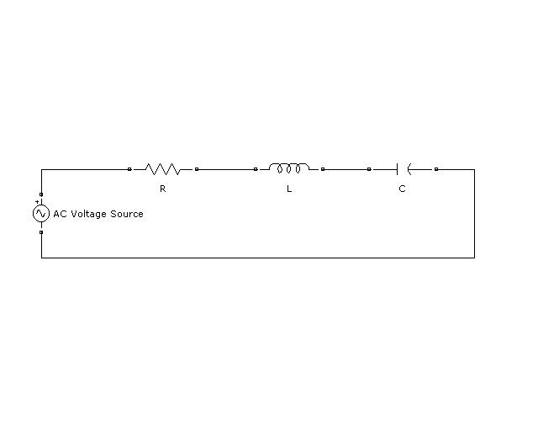

**PROGRAM CODE:**

clear all;

close all;

clc;

disp('Please enter the value of AC voltage source:');

V=input('');

disp('Please enter the value of resistance R:');

R=input('');

disp('Please enter the value of inductance L:');

L=input('');

disp('Please enter the value of capacitance C:');

C=input('');

fr=1/(2*pi*sqrt(L*C));

disp('The resonant frequency(in hertz) for the given circuit is:');

disp(fr);

BW=R/(2*pi*L);

disp('The band width BW of the series RLC circuit is:');

disp(BW);

Q=fr/BW;

disp('The Q factor of the series RLC circuit is:');

disp(Q);

syms f

subplot(3,3,1);

fplot(@(f) V*R/sqrt(R^2+(L*2*pi*f-1/(C*2*pi*f))^2),[fr-50 fr+50]);

xlabel('Frequency(Hz)-------->');

ylabel('Voltage across resistor(V)--------->');

title('Vr v\s f');

subplot(3,3,2);

fplot(@(f) V/sqrt(R^2+(L*2*pi*f-1/(C*2*pi*f))^2),[fr-50 fr+50]);

xlabel('Frequency(Hz)-------->');

ylabel('Current(A)--------->');

title('I v\s f');

subplot(3,3,3);

fplot(@(f) sqrt(R^2+(L*2*pi*f-1/(C*2*pi*f))^2),[fr-50 fr+50]);

xlabel('Frequency(Hz)-------->');

ylabel('Impedance(ohm)--------->');

title('Z v\s f');

subplot(3,3,4);

fplot(@(f) L*2*pi*f,[0 fr+50]);

xlabel('Frequency(Hz)-------->');

ylabel('Inductive Reactance(ohm)--------->');

title('XL v\s f');

subplot(3,3,5);

fplot(@(f) 1/(C*2*pi*f),[0 fr+50]);

xlabel('Frequency(Hz)-------->');

ylabel('Capacitive Reactance(ohm)--------->');

title('XC v\s f');

subplot(3,3,6);

fplot(@(f) V*(1/(C*2*pi*f))/sqrt(R^2+(L*2*pi*f-1/(C*2*pi*f))^2),[fr-50 fr+50]);

xlabel('Frequency(Hz)-------->');

ylabel('Voltage across capacitor(V)--------->');

title('Vc v\s f');

subplot(3,3,7);

fplot(@(f) V*(L*2*pi*f)/sqrt(R^2+(L*2*pi*f-1/(C*2*pi*f))^2),[fr-50 fr+50]);

xlabel('Frequency(Hz)-------->');

ylabel('Voltage across inductor(V)--------->');

title('Vl v\s f');

**OUTPUT:**

Please enter the value of AC voltage source:

230

Please enter the value of resistance R:

10

Please enter the value of inductance L:

.1

Please enter the value of capacitance C:

10e-6

The resonant frequency(in hertz) for the given circuit is:

159.1549

The band width BW of the series RLC circuit is:

15.9155

The Q factor of the series RLC circuit is:

10.0000

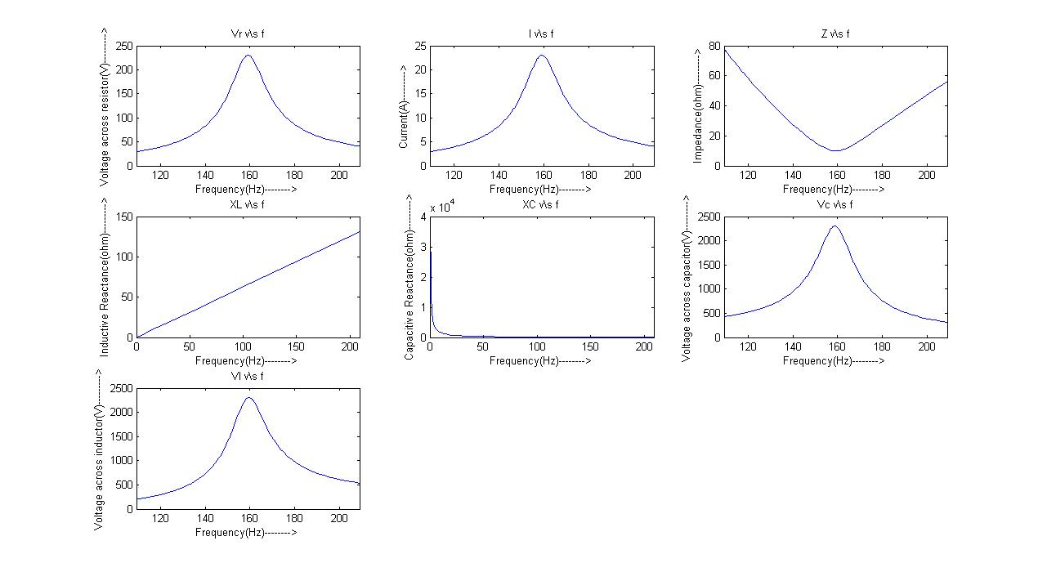**GRAPHS**

**Question 4**

**CIRCUIT DIAGRAM:**

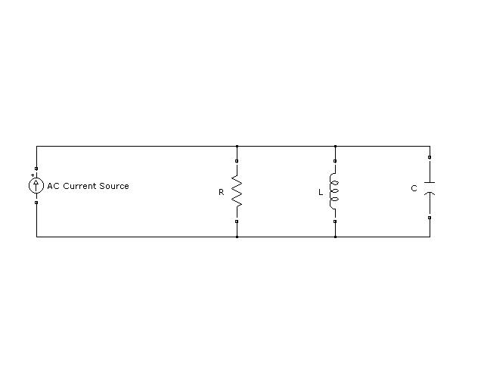

**PROGRAM CODE:**

clear all;

close all;

clc;

disp('Please enter the value of resistance R:');

R=input('');

disp('Please enter the value of inductance L:');

L=input('');

disp('Please enter the value of capacitance C:');

C=input('');

fr=1/(2*pi*sqrt(L*C));

disp('The resonant frequency(in hertz) for the given circuit is:');

disp(fr);

disp('The resonant frequency(in rad/s) for the given circuit is:');

disp(2*pi*fr);

BW=1/(2*pi*R*C);

disp('The band width BW of the parallel RLC circuit is:');

disp(BW);

Q=fr/BW;

disp('The Q factor of the parallel RLC circuit is:');

disp(Q);

f1=fr-(BW/2);

f2=fr+(BW/2);

disp('The lower and upper cut-off frequencies for the given parallel RLC circuit are:');

disp(f1);

disp(f2);

% To calculate impedance of the circuit

disp('Please enter the maximum value of AC current source:');

I=input('');

Irms=I/sqrt(2);

disp('Please enter the frequency in rad/s:');

w=input('');

Z=1/sqrt((1/R)^2+(C*w-1/(L*w))^2);

Vrms=Irms*Z;

disp('The voltage(rms) appearing across the parallel elements are:');

disp(Vrms);

syms f;

subplot(3,2,1);

fplot(@(f) 1/sqrt((1/R)^2+(2*pi*f*C-1/(2*pi*f*L))^2),[fr-50 fr+100]);

xlabel('Frequency(Hz)-------->');

ylabel('Impedance(ohm)--------->');

title('Z v\s f');

subplot(3,2,2);

% Vm=Im*Z

fplot(@(f) 10/sqrt((1/R)^2+(2*pi*f*C-1/(2*pi*f*L))^2),[fr-50 fr+100]);

xlabel('Frequency(Hz)-------->');

ylabel('Max voltage(V)--------->');

title('Vm v\s f');

subplot(3,2,3);

% Vrms=Irms*Z

fplot(@(f) (10/sqrt(2))/sqrt((1/R)^2+(2*pi*f*C-1/(2*pi*f*L))^2),[fr-50 fr+100]);

xlabel('Frequency(Hz)-------->');

ylabel('Rms voltage(V)--------->');

title('Vrms v\s f');

subplot(3,2,4);

fplot(@(f) (10/sqrt((1/R)^2+(2*pi*f*C-1/(2*pi*f*L))^2))/R,[fr-50 fr+100]);

xlabel('Frequency(Hz)-------->');

ylabel('Max current in resistor(A)--------->');

title('Ir v\s f');

subplot(3,2,5);

fplot(@(f) (10/sqrt((1/R)^2+(2*pi*f*C-1/(2*pi*f*L))^2))/(L*2*pi*f),[fr-50 fr+100]);

xlabel('Frequency(Hz)-------->');

ylabel('Max current in inductor(A)-------->');

title('Il v\s f');

subplot(3,2,6);

fplot(@(f) (10/sqrt((1/R)^2+(2*pi*f*C-1/(2*pi*f*L))^2))*(C*2*pi*f),[fr-50 fr+100]);

xlabel('Frequency(Hz)-------->');

ylabel('Max current in capacitor(A)-------->');

title('Ic v\s f');

**OUTPUT:**

Please enter the value of resistance R:

12

Please enter the value of inductance L:

2

Please enter the value of capacitance C:

3e-6

The resonant frequency(in hertz) for the given circuit is:

64.9747

The resonant frequency(in rad/s) for the given circuit is:

408.2483

The band width BW of the parallel RLC circuit is:

4.4210e+003

The Q factor of the parallel RLC circuit is:

0.0147

The lower and upper cut-off frequencies for the given parallel RLC circuit are:

-2.1455e+003

2.2755e+003

Please enter the maximum value of AC current source:

10

Please enter the frequency in rad/s:

1800

The voltage(rms) appearing across the parallel elements are:

84.6930

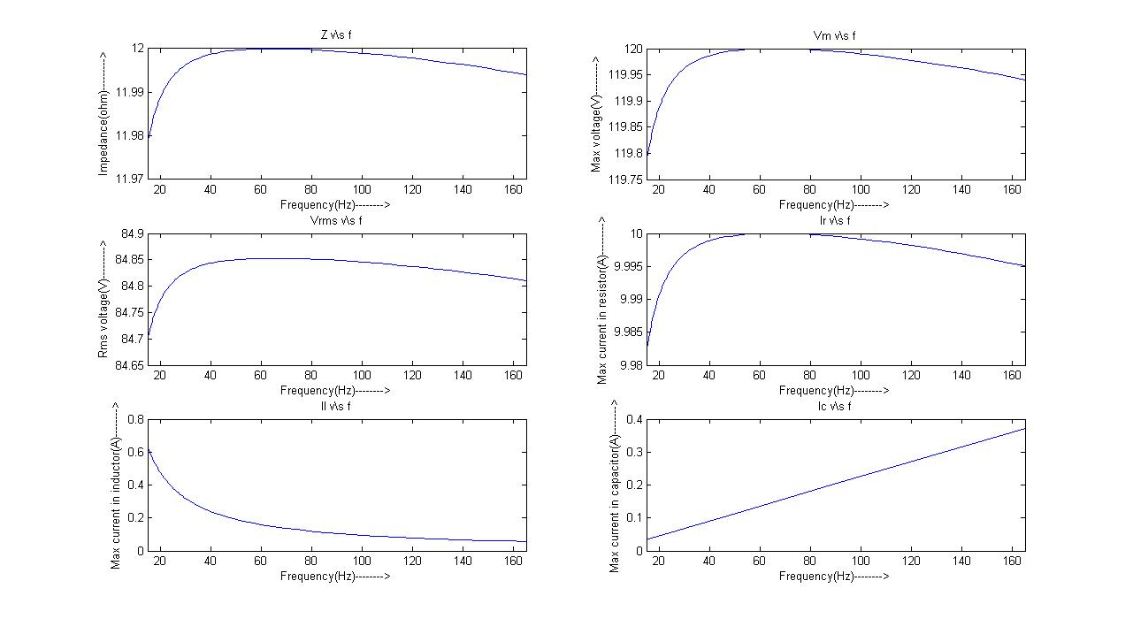**GRAPH:**

**Question 5(a)**

**CIRCUIT DIAGRAM:**

**PROGRAM CODE:**

% Balanced Y-Y positive system

clear all;

close all;

clc;

disp('Please enter the value of phase voltage(reference):');

Van=input('');

Vbn=(Van*cos(deg2rad(-120))+i*Van*sin(deg2rad(-120)));

Vcn=(Van*cos(deg2rad(-240))+i*Van*sin(deg2rad(-240)));

disp('Plase enter the transmission line impedance:');

Zt=input('');

disp('Please enter the load impedance:');

Zl=input('');

Z=[(Zt+Zl) (-Zt-Zl) 0;0 (Zt+Zl) (-Zt-Zl);1 1 1];

V=[(Van-Vbn);(Vbn-Vcn);0];

I=inv(Z)*V;

disp('The respective line currents are:');

disp(I);

pf=real(Zt+Zl)/sqrt((real(Zt+Zl))^2+(imag(Zt+Zl))^2);

disp('The power factor of the load is:');

disp(pf);

P=sqrt(3)*Van*(sqrt((real(I(1)))^2+(imag(I(1)))^2))*pf;

disp('The total power(in Watts) supplied to the load is:');

disp(P);

**OUTPUT:**

Please enter the value of phase voltage(reference):

120

Plase enter the transmission line impedance:

1+0.5i

Please enter the load impedance:

11+4.5i

The respective line currents are:

8.5207 - 3.5503i

-7.3350 - 5.6040i

-1.1857 + 9.1543i

The power factor of the load is:

0.9231

The total power(in Watts) supplied to the load is:

1.7710e+003

**Question 5(b)**

**CIRCUIT DIAGRAM:**

**PROGRAM CODE:**

% Un-balanced Y-delta positive system

clear all;

close all;

clc;

disp('Please enter the value of phase voltage(ref----phase angle=0):');

Van=input('');

Vbn=(Van*cos(deg2rad(-120))+i*Van*sin(deg2rad(-120)));

Vcn=(Van*cos(deg2rad(-240))+i*Van*sin(deg2rad(-240)));

disp('Please enter Raa1:');

Raa1=input('');

disp('Please enter Rbb1:');

Rbb1=input('');

disp('Please enter Rcc1:');

Rcc1=input('');

disp('Please enter Zab:');

Zab=input('');

disp('Please enter Zbc:');

Zbc=input('');

disp('Please enter Zca:');

Zca=input('');

Z=[(Raa1+Rbb1+Zab) -Rbb1 -Zab;Zab Zbc -(Zab+Zbc+Zca);-Rbb1 (Rbb1+Rcc1+Zbc) -Zbc];

V=[Van-Vbn;0;Vbn-Vcn];

I=inv(Z)*V;

disp('The respective loop currents are:');

disp(I);

disp('Thus the respective line currents are:');

disp(I(1));

disp(I(2)-I(1));

disp(-I(2));

**OUTPUT:**

Please enter the value of phase voltage(ref----phase angle=0):

120

Please enter Raa1:

1

Please enter Rbb1:

2

Please enter Rcc1:

1

Please enter Zab:

10+5i

Please enter Zbc:

15+7i

Please enter Zca:

12-3i

The respective loop currents are:

26.0597 - 2.2870i

9.8895 -13.9614i

13.0172 - 4.0519i

Thus the respective line currents are:

26.0597 - 2.2870i

-16.1702 -11.6744i

-9.8895 +13.9614i